Japan-China-Korea National Cancer Centers
COVID-19 Infection Control Meeting

(Seoul/Tokyo Time) | 22 April 2020 (wed)
15:30-15:38 | Greetings  Dr Hitoshi NAKAGAMA – President, National Cancer Center of Japan  Dr Jie HE – President, National Cancer Center of China  Dr Eun Sook LEE, President - National Cancer Center of Korea  Introduction of speakers :  Dr Laureline Gatellier, Office of International Affairs, NCC Japan
15:38-15:48 | The Japanese Experience
 | Dr Satoshi IWATA, Director - Department of Infectious Diseases, Hospital, NCCJ
15:50-16:00 | The NCC China Experience
 | Dr Jing JIN, Director - Office for Medical Affaires, National Cancer Center of China
16:02-16:12 | The NCC Korea Experience
 | Dr Young Ju CHOI, Chief - Infection Control Unit, National Cancer Center of Korea
16:14-16:30 | Q & A, Discussion
16:30 | Closing

Chinese delegation:
Dr. Jie HE President – NCC China
Dr. Jing JIN Director - Office for Medical Affaires - NCC China
Dr. Min DAI Director – Department of International Communications, NCC China
Dr. Baomin CHEN Chief - Office for Disease and Infection Control, NCC China
Dr. Nianzeng XING Director – Department of Urological Oncology, NCC China
Mrs Hu CHANG Staff - Department of International Communications, NCC China
Mrs Gu TIAN Staff - Department of International Communications, NCC China

Korean delegation:
Dr. Eun Sook LEE President - NCC Korea
Dr. Young Ju CHOI Chief - Infection Control Unit (Specialist)
Ms. Kyu-Won JUNG Director - Office of Public Relations and Collaboration
Dr. June Hyuk KIM Manager - International Cooperation and Public Relations Team
Mr. Sung Hoo HONG Deputy Manager - International Cooperation and Public Relations Team
Mr. Jong Soo HAN Coordinator - International Cooperation and Public Relations Team

Japanese delegation:
Dr. Hitoshi NAKAGAMA President - NCC Japan
Dr. Satoshi IWATA Director - Department of Infectious Diseases, NCC Hospital
Dr. Teiji TAKEI Executive Adviser to President – NCC Japan
Dr. Tatsuya SUZUKI Deputy Director - Strategic Planning Bureau, NCC Japan
Dr. Tomohiro MATSUDA Head - Office of International Affairs, NCC Japan
Mrs Kay OHARA Manager - Office of International Affairs, NCC Japan
Dr. Laureline GATELLIER Researcher - Office of International Affairs, NCC Japan

--- Notes of the eMeeting ---

On 22 April, NCC Japan, NCC China and NCC Korea held a COVID-19 infection Control web-meeting to share their experiences to contain the outbreak in their respective countries and cancer centers.

During the meeting, Dr. Hitoshi Nakagama, Dr. Jie He and Dr. Eun Sook Lee, respectively presidents from NCC Japan, NCC China and NCC Korea, emphasized the responsibility of each center to fight against COVID-19 while maintaining appropriate care for cancer patients. They also emphasized the importance of social distancing, respect for the greater benefits to public health and mutual support within the community. They encouraged all the countries to have more close collaborations during this pandemic of COVID-19. Their introductory speeches were followed by specialist presentations.

Representing NCC Japan, Dr Iwata introduced the government’s policy of “Avoiding 3 Cs“(enClosed spaces, Crowded gatherings, Close contact), and shared infection control at the Hospital since January thru the national state of emergency declared on 16 April. At the hospital, clear criteria was set to identify suspected COVID-19 patients so as to separate them from the rest since late January, as were strict infection control preventive measures of hand sanitization and mask wearing introduced. In response to the call from the Tokyo metropolitan government, a specialty ward for COVID-19 patients was established mid-April, to serve both cancer patients and those without. NCC Japan also highlighted specific burdens of the pandemic such as the fact that psycho-social support is necessary for staffs caring for patients.

Dr Jin of NCC China shared their achievements in performing more than 950 chemotherapies and 4600 radiation therapies amidst the pandemic, overcoming challenges in providing cancer care. To maintain the safety of cancer patients, PPE were used at CT units by both patients and caregivers, individual private rooms were prepared for their patients to minimize cross infection in the hospital. Telemedicine is available all around the country, with more online consultations from February to April.

Dr Choi of NCC Korea shared their experiences in screening, with the use of separate screening areas for patients with travel history, high temperature or respiratory symptoms. At the entrance of the hospital, all patients and visitors were put through a body check, questionnaires, and emergency booths for cancer patients with symptoms were put in place. Experts assisted at drive-thru sites for COVID-19 testing. Dr Choi also shared their experience in a webinar hosted by UICC and also contributed to forming guidelines to respond the COVID-19 pandemic in an appropriate and timely manner.

Key points highlighted by infection control specialists and attending members were the importance of procedures such as screening patients entering each center and separating suspected patients with COVID-19, managing hospital infection, dispatching experts to support patients nationwide, and use of technology in the three countries to efficiently overcome the pandemic and to build on future experience. Three centers were all glad that no any cases with COVID-19 was confirmed among the cancer patients, caregivers and medical staffs in their hospitals through the above mandatory measures.

In closing the meeting, all agreed on the importance to share information among Asian countries, including through ANCCA (Asian National Cancer Center Alliance) collaboration.

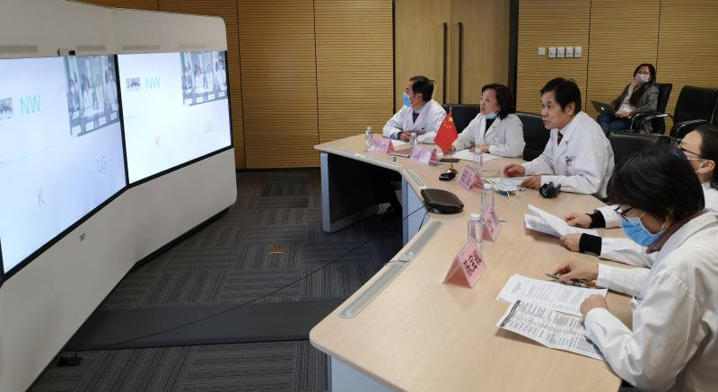
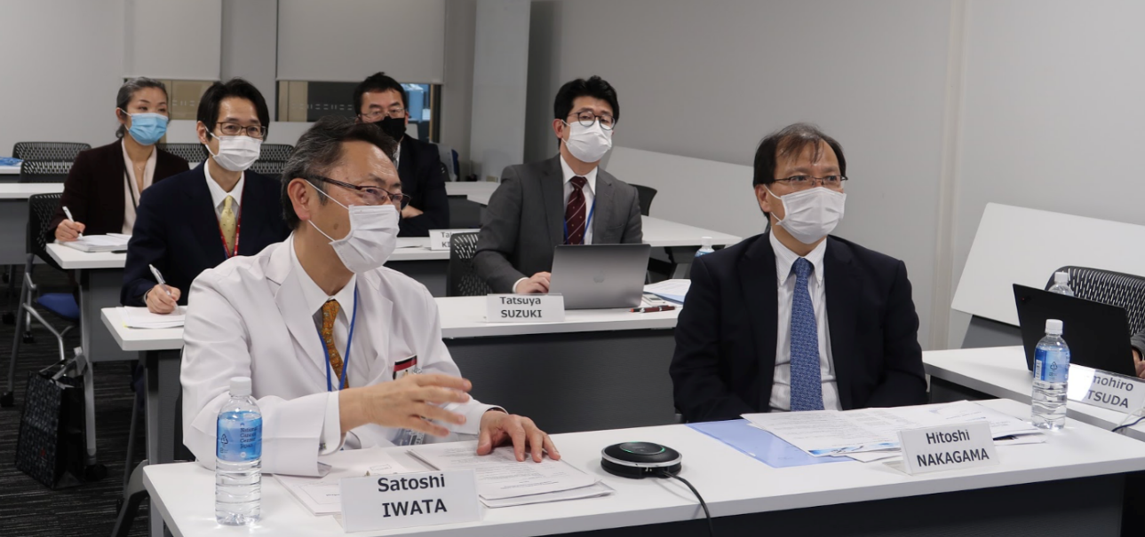
Dr. Satoshi Iwata presenting the Japan Experience – From Right to Left: Dr Hitoshi Nakagama, Dr. Tatsuya Suzuki, Dr. Takashi Kitaba, Dr. Satoshi Iwata, Dr. Teiji Takei, Mrs. Kay Ohara
NCC China sharing the experience– From Left to Right: Dr Nianzeng XING, Dr Min DAI, Dr Jie HE, Dr Jing JIN, Dr Baomin CHEN.
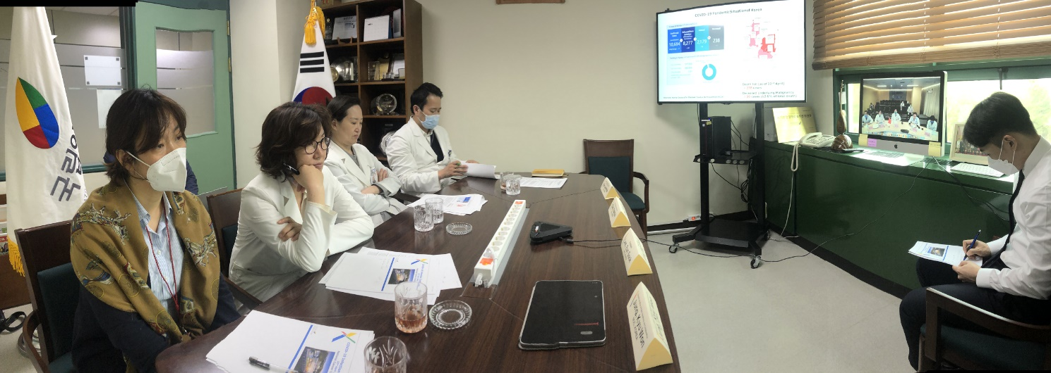
NCC Korea sharing the experience– From Left to Right: Ms. Kyu-Won JUNG, Dr. Eun Sook LEE, Dr. Young Ju CHOI, Dr. June Hyuk KIM

